**The following steps will teach you how to download and write the Raspberry Pi system image**

**1.Start up mode of Raspberry Pi and system image**

Raspberry Pi board without on-board FLASH. It supports SD card boot, we need to download the corresponding system image,and burn it on the SD. When the Raspberry Pi is connected to the power supply, the system can be started. (This system image include: bootloader, kernel, file system).

Raspberry Pi supports a variety of system types, such as:

Raspbian、Arch Linux ARM、Debian Squeeze、Firefox OS、Gentoo Linux  
Google Chrome OS、Raspberry Pi Fedora Remix、Slackware ARM  
QtonPi、Slackware ARM、WebOS、RISC OS、FreeBSD、NetBSD、

Android 4.0(Ice Cream Sandwich)

In the development of the Raspberry pi 4WD robot car, we will use Raspbian operating system.

**2.Raspberry Pi system image download address.**

Raspberry Pi official website download address：<http://www.raspberrypi.org/downloads>

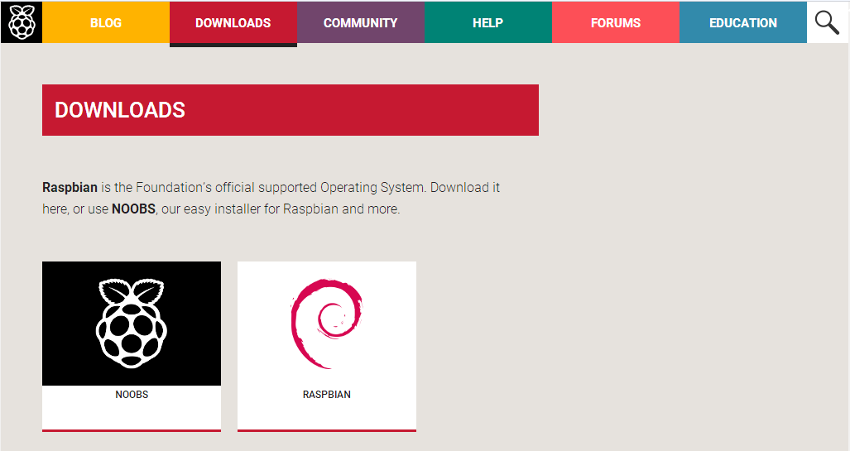

You can also use our system image directly.

**3.How to write the Raspberry Pi system image**

1. You need a SD card with more than 2G and card reader，above Class4.

2. You need to use a tool to write the Raspberry Pi system image：Win32DiskImager.zip

(Note : This software in the Tools folder)

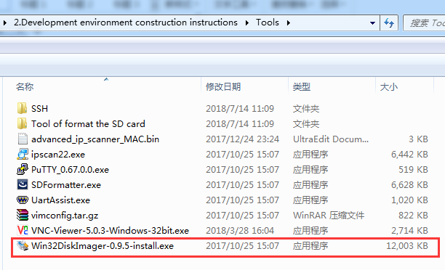

You can double-click and install it by following the steps below.

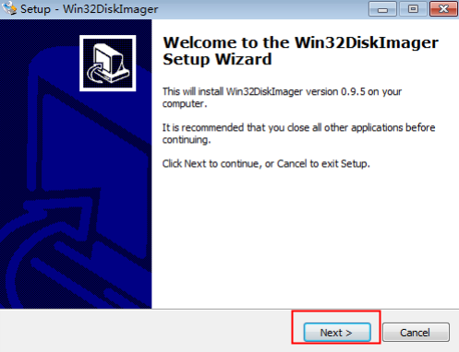

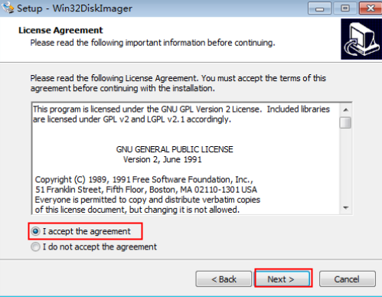

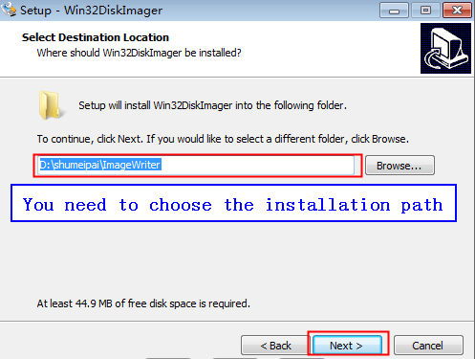

The next interface needs to click NEXT.

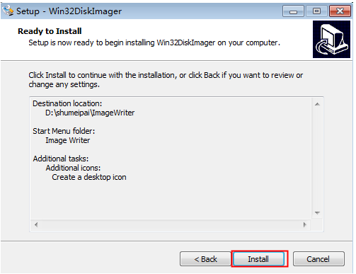

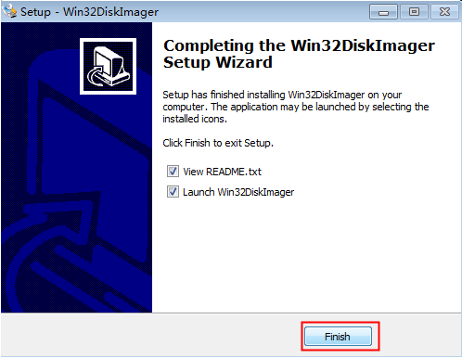

Finally, the following figure appears on the desktop, installed successfully.

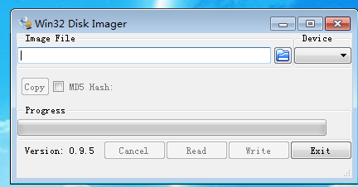

**Format the SD card:**

Before writing the system image, you need to format your SD card. You need to connect the SD card to the computer with a card reader.

You need to use a tool to format the SD card：SDFormatter.exe

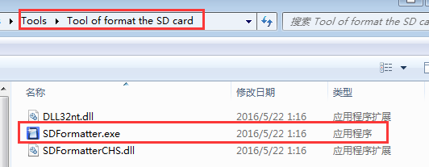

(Note : This software in the Tool of format the SD card folder of Tools folder)  
1.You need to unzip the downloaded system image compression file to obtain the img image file.  
2. You need to connect the SD card to the computer with a card reader.  
3. Running the Win32DiskImager-0.9.5-install.exe .  
4. You need to select img file in the software, select the SD , and then click"Write". As shown below.

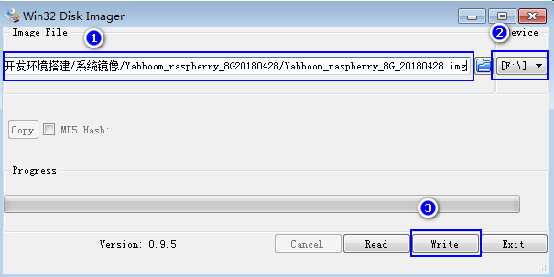

1. After the write is completed, a completion dialog box will pop up. If it is not successful, you need to turn off the software such as firewall and re-insert SD to write. You will see that SD possess only 74MB capacity, which is normal, because the disk partition in the linux can not be seen in the win!

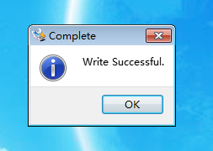

After the above steps, the system image of the Raspberry Pi has been written into the SD card successfully .